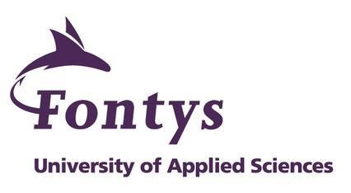
Anas Ahmad| Fontys | Student number: 435688

<Musea>
Five Museums:
- https://www.museum.nl/en/batavialand
- https://www.museum.nl/en/rijksmuseum-muiderslot/other/color-the-castle
- https://www.museum.nl/en/hunebedcentrum
- https://www.museum.nl/en/nederlands-openluchtmuseum
- https://www.museum.nl/en/groninger-museum
'what does my selection tells me about myself and my area of interest?'

I realise that 4 out 5 museums are related to history, basically how people used their creativity in ancient times. I believe like humans are always creative therefore I am always more curious about the old ways of living, like how developed were humans in their times without having modern technologies like us. It makes me realize that to be creative you don’t need special tools; you just have to think beyond your comfort level.

<Newspaper>

5 articles that I found interesting.

- https://www.newsinlevels.com/products/robot-faces-level-1/

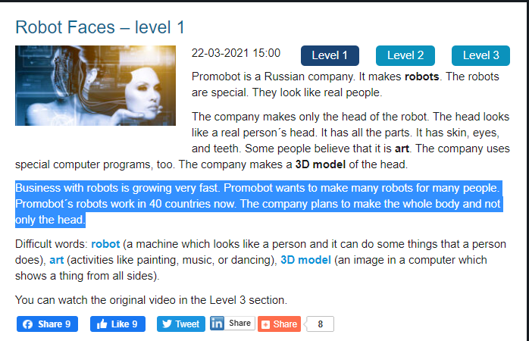

- https://www.newsinlevels.com/products/vaccine-cake-level-1/

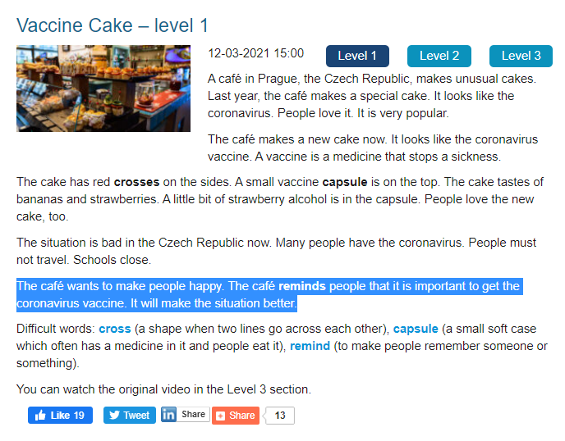

- https://www.newsinlevels.com/products/how-video-calling-started-level-1/

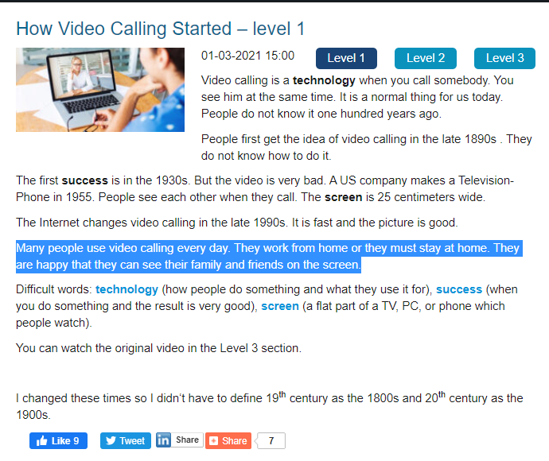
- https://www.newsinlevels.com/products/apple-electric-car-level-1/

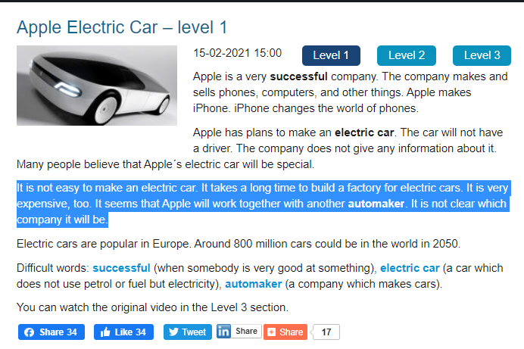

- https://www.english-online.at/news-articles/business-economy/amazon-go-first-automated-store.htm

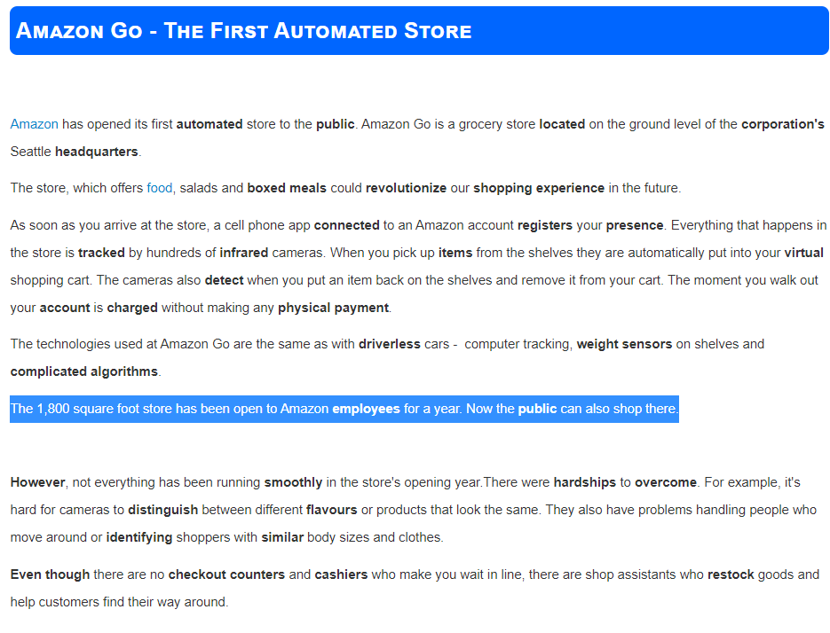

'what does my selection tells me about myself and my area of interest?'

After going through a lot of articles I found 5 short articles which can be seen above and in blue highlighted parts of the articles can be seen. I realized that, my interests are mostly related to people. I am more curious on how to improve opportunities for people with technology. That is also one of the reasons, that my individual project has people interaction. One of the the important factors is that I like to work on present topics for example how can I create such an opportunity for people to use AR glasses to detect vaccinated people.

